Q1. Code the following instructions in assembly.

a).

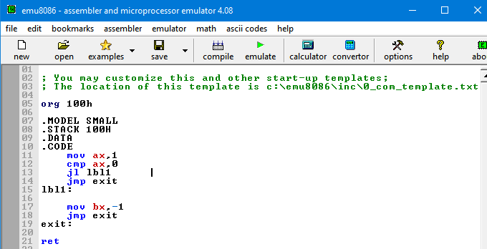

b).

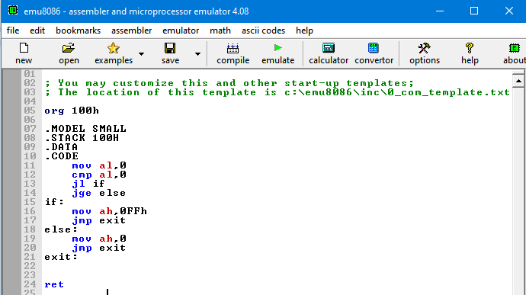

c).

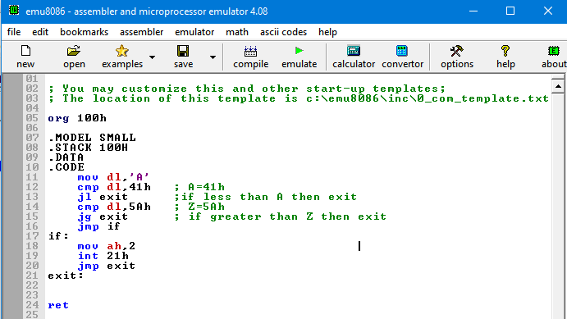

d).

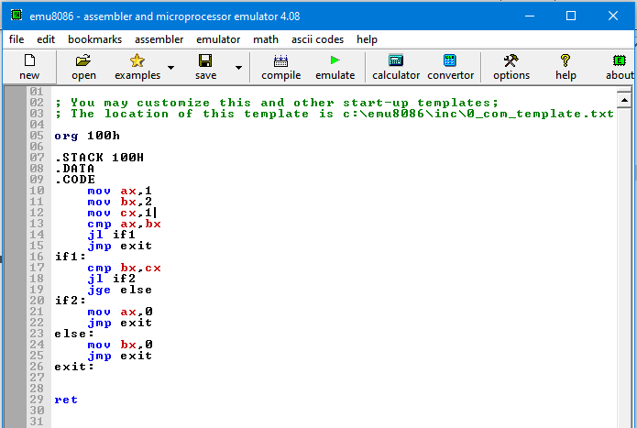

e).

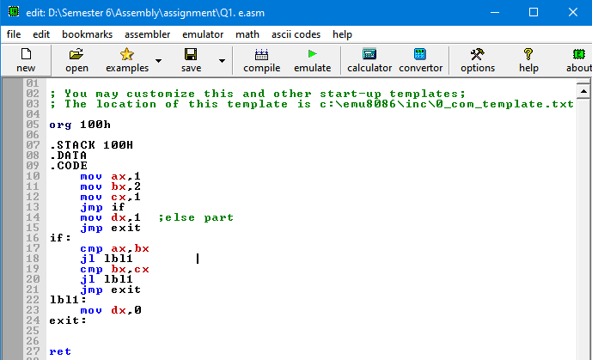

f).

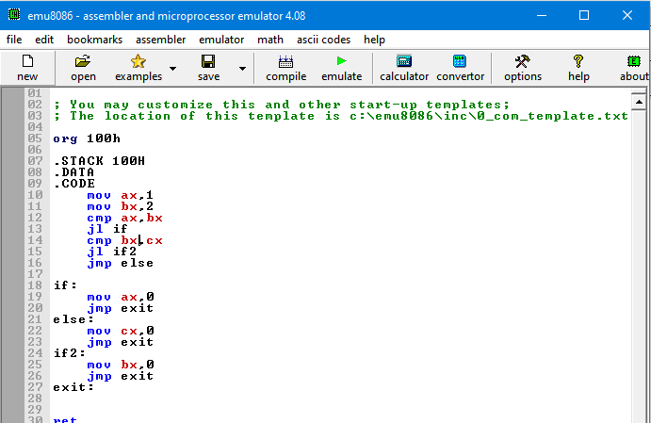

Q2.

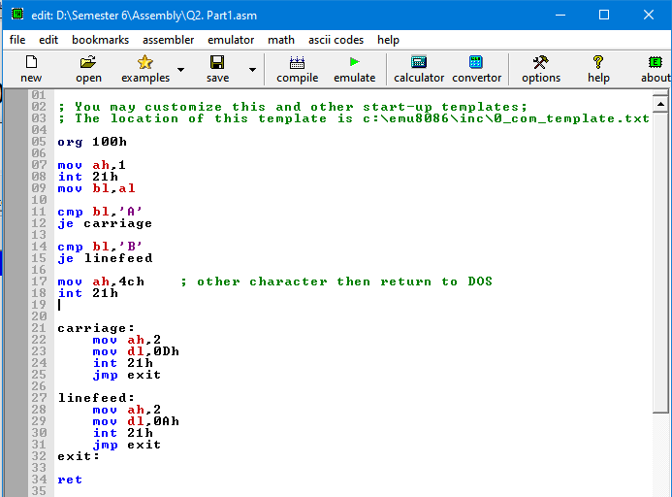

Q3.

a). Put the sum 1+4+7+……. 148 in AX.

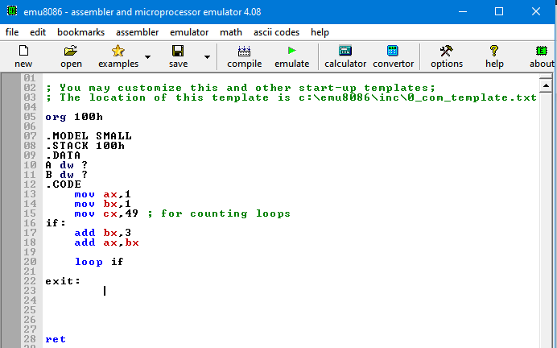

b). Put the sum of 100+95+______+5 in AX

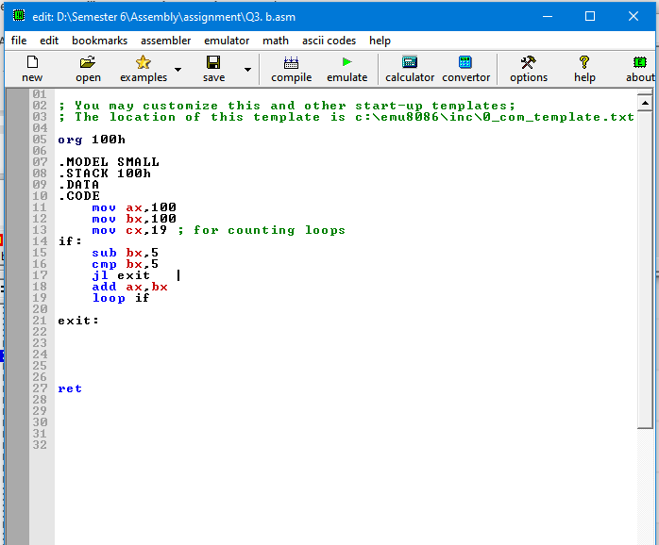

Q4.

a). Put the sum of first 50 terms of 1,5,9…. In DX.

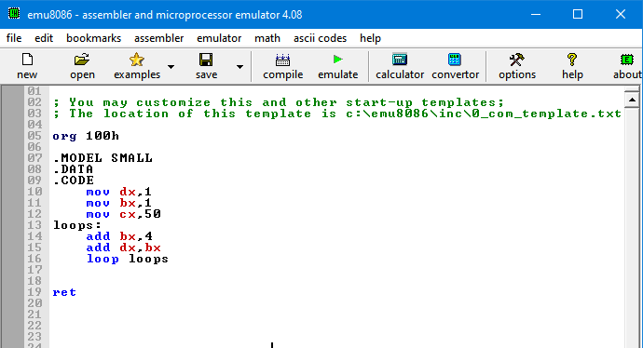

b). Read the character and print it 80 times on next line.

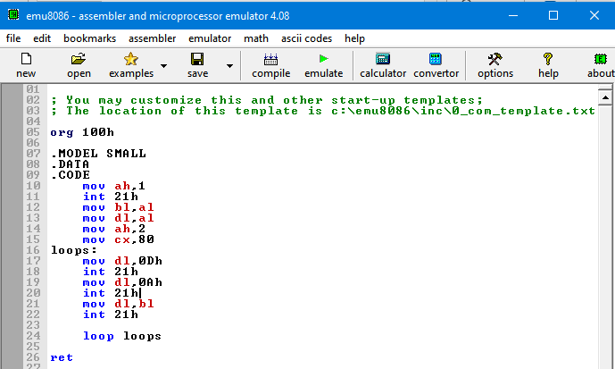

c). Read a five character password and overprint it by executing a carriage return and displaying five X's. You need not store the input characters anywhere.

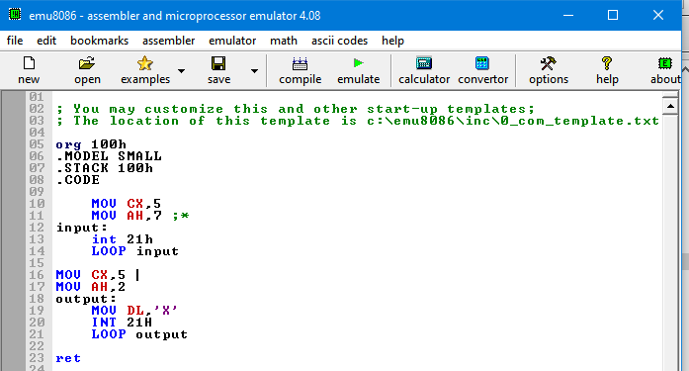

Q5. The following algorithm may be used to carry out division of two nonnegative numbers by repeated subtraction:

initialize quotient to 0

WHILE dividend >= divisor DO

increment quotient

subtract divisor from dividend

END_ WHILE

Write a sequence of instructions to divide.AX by BX, and put the quotient in cx.

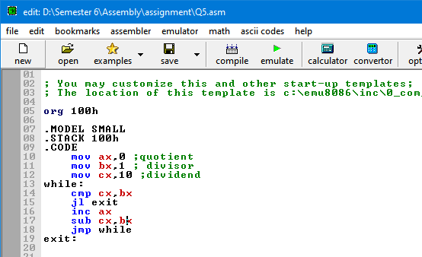

Q6. initialize product to 0

REPEAT

add M to product

decrement N

UNTIL N = 0

Write a sequence of instructions to multiply AX by BX and put the product in cx. You may Ignore the possibility of overflow.

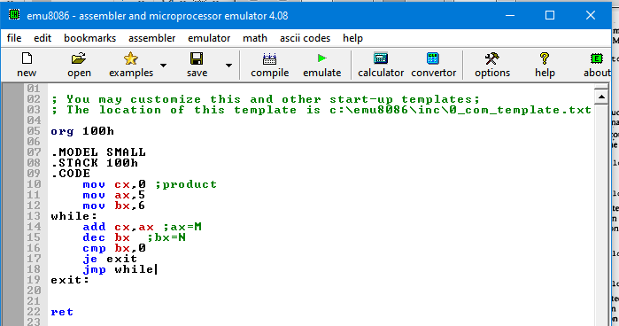

Q7.

a).

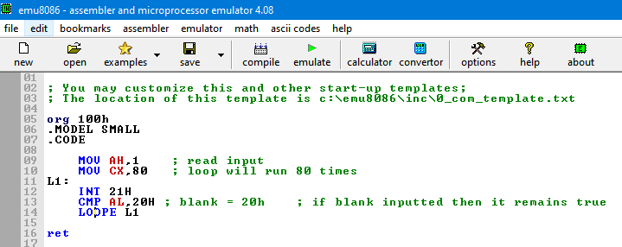

b).

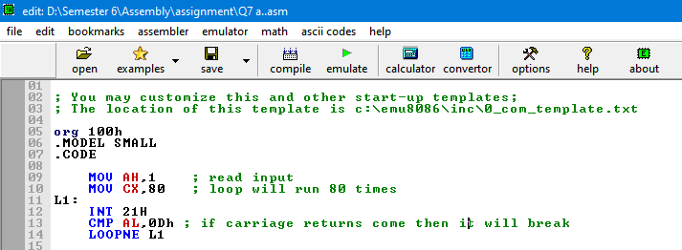

Q8. Write a program to display a "?", read two capital letters, and display them on the next line In alphabetical order.

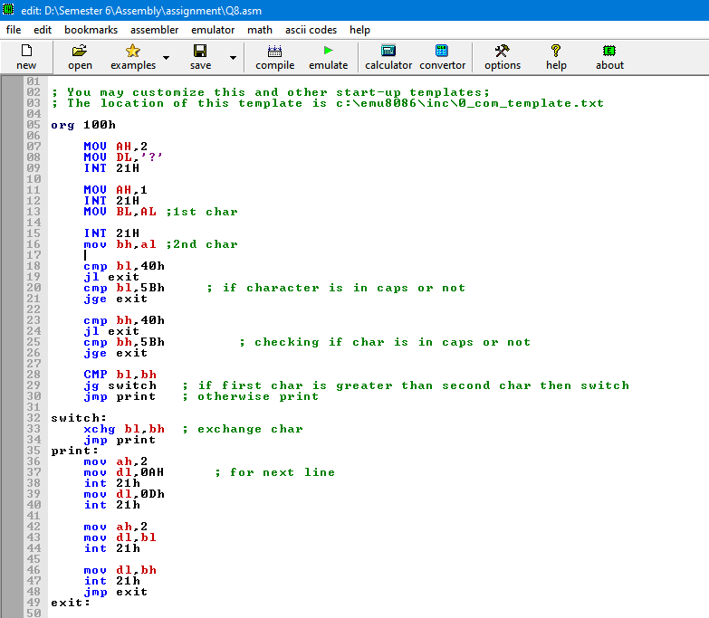

Q9. Write *a* program to display the extended ASCII characters (ASCII codes 80h to FFh). Display 10 characters per line, separated by blanks. Stop after the extended characters have been displayed

once.

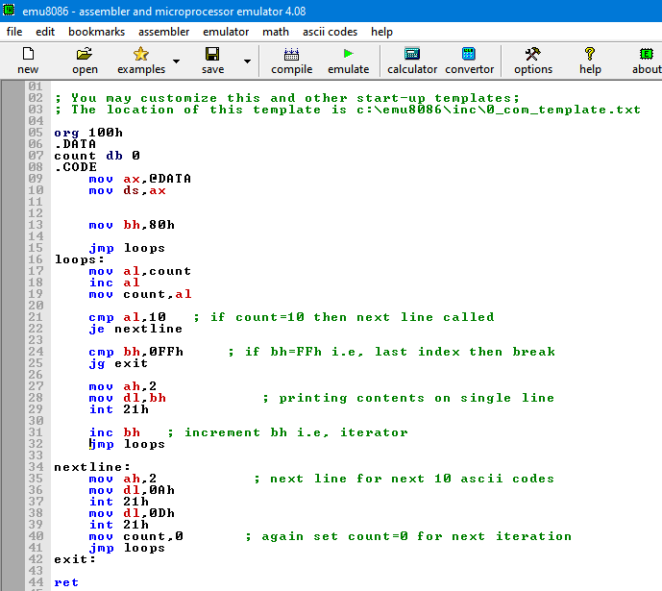

Q10.

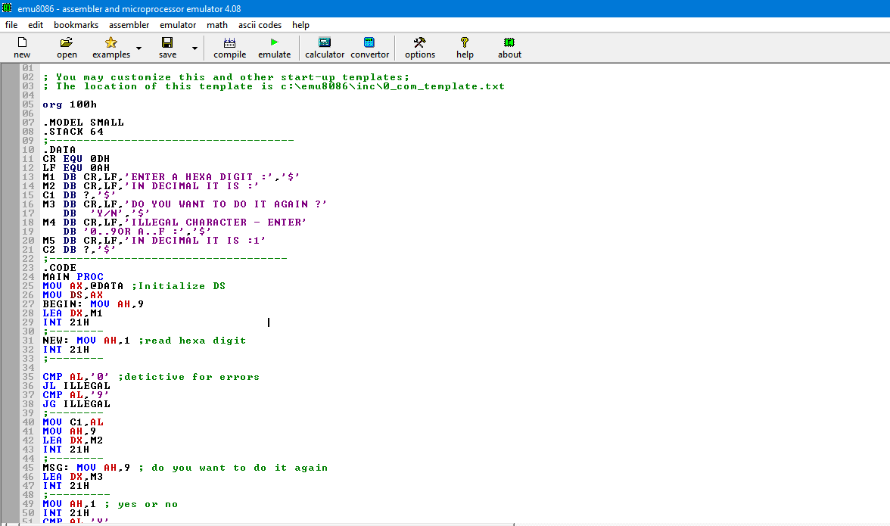

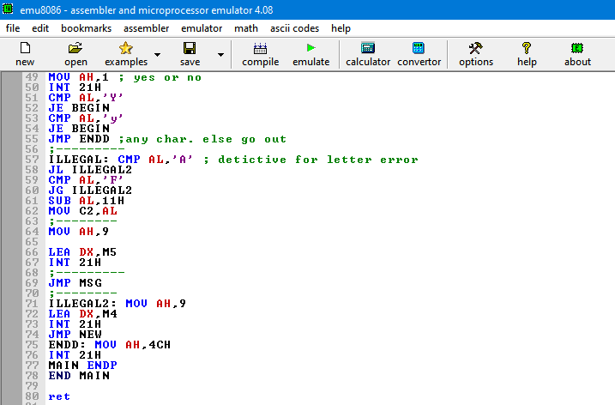

Q12.